DNN Application Servers DR setup:

DNN-Primary setup: East US

=======================

|  |  |  |  |  |  |
| --- | --- | --- | --- | --- | --- |
| EAST US - Primary |  |  |  |  |  |
| **Resource Group** | **Virtual Network** | **Subnet** | **Availability Set** | **Load Balancer** | **Virtual Machines** |
| PRD-DMZ-AMER-DNN | PRD-NET-AMER | PRD-DMZ-AMER | SWIAAPDMZDNN-AS-P01 | lciazrsecalbp02 | SWIAAPDMZDNNP01 SWIAAPDMZDNNP02 |
|  |  |  |  |  |  |
| PRD-INF-AMER-DNN | PRD-NET-AMER | PRD-INF-AMER | SWIAAPINFDNNFSTOR-AS-P01 | lciaapinfalbintdnnfsp01 | SWIAAPINFDNNP01 SWIAAPINFDNNP02 |
|  |  |  |  |  |  |
| PRD-DBS-AMER-DNN | PRD-NET-AMER | PRD-DBS-AMER | SWIAAPDBSDNNSSIS-AS-P01 |  | SWIAANSQLDNNP01 |

DNN-DR setup: West US2

=======================

|  |  |  |  |  |  |
| --- | --- | --- | --- | --- | --- |
| **WEST US2 (DR)** |  |  |  |  |  |
| **Resource Group** | **Virtual Network** | **Subnet** | **Availability Set** | **Load Balancer** | **Virtual Machines** |
| DRS-DMZ-AMER-DNN | DRS-NET-AMER | DRS-DMZ-AMER  10.253.136.0/25 | SWIAARDMZDNN-AS-R03 | DNN-DR-Internal-LB | SWIAARDMZDNNR03 SWIAARDMZDNNR04 |
|  |  |  |  |  |  |
| DRS-INF-AMER-WUS2-DNN | DRS-NET-AMER | DRS-APP-AMER  10.253.136.128/25 | SWIAARINFDNNFSTOR-AS-R03 | DNN-DR-Internal-FS-LB | SWIAARINFDNNR03  SWIAARINFDNNR04 |
|  |  |  |  |  |  |
| DRS-DBS-AMER-DNN | DRS-NET-AMER | DRS-DBS-AMER  10.253.137.0/25 | SWIAARDBSDNNSSIS-AS-R02 |  | SWIAARSQLDNNR02 |

**Recovery Service Vault**: DRS-RecoveryVault-WestUS2

DMZ Web Servers:

=================

1. Click enable site recovery

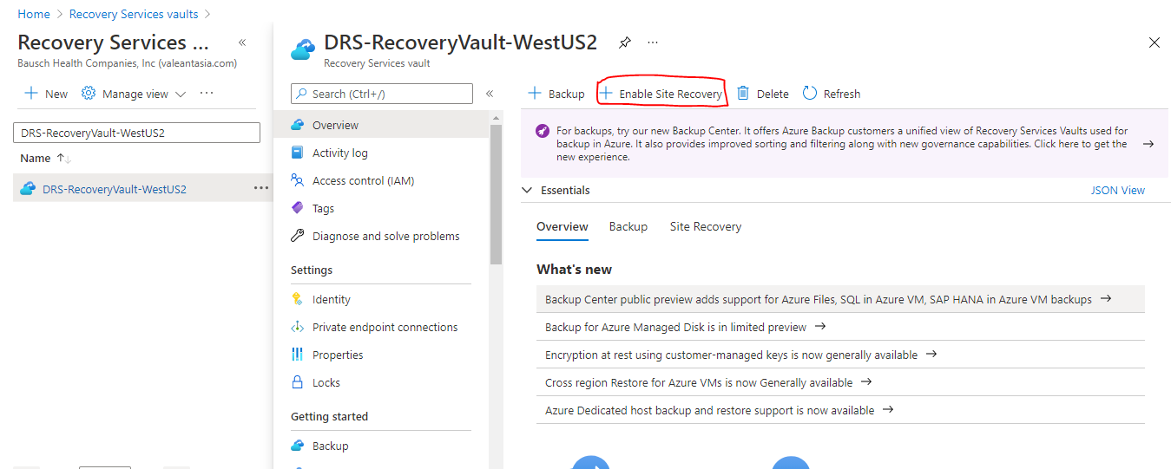

1. Enable replication

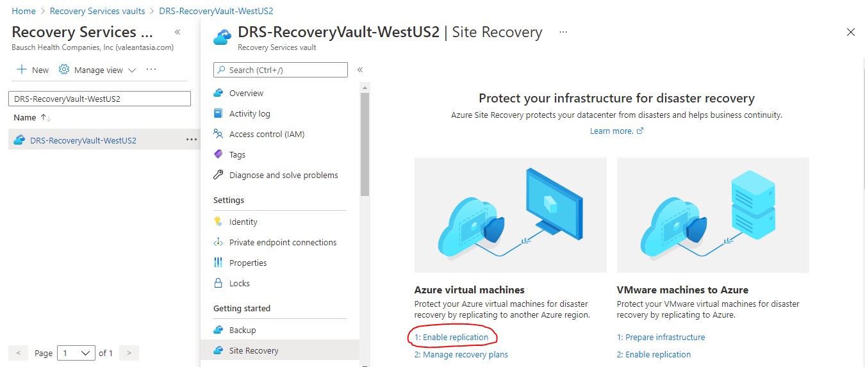

1. Provide the source details

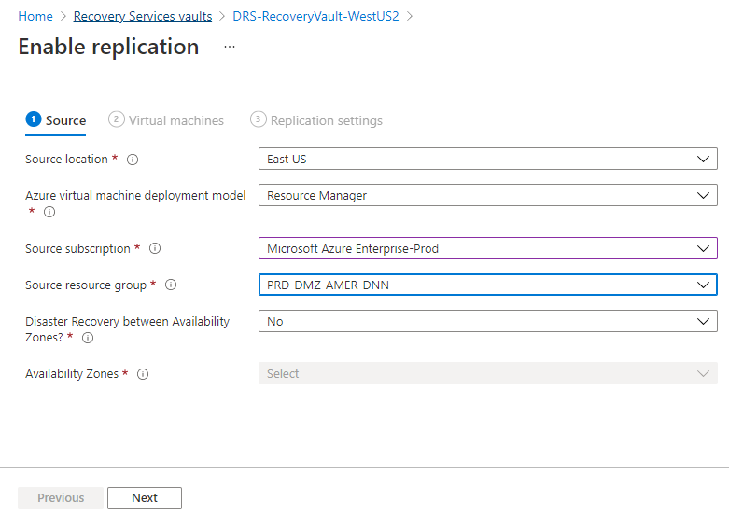

1. Select the respective servers

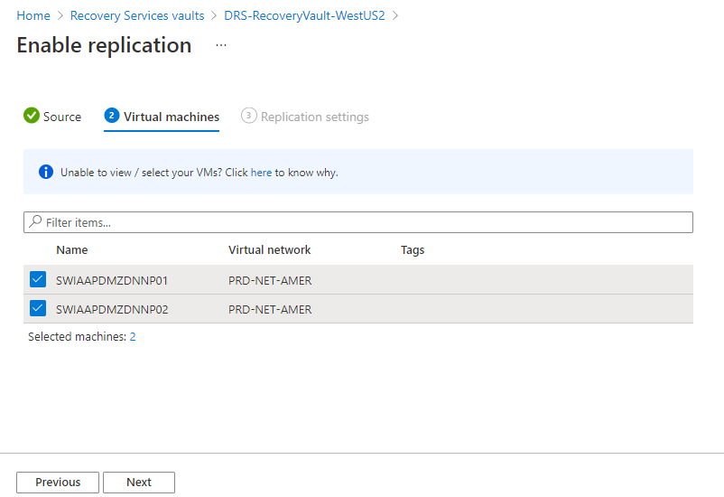

1. Select the target region, subscription and other details.

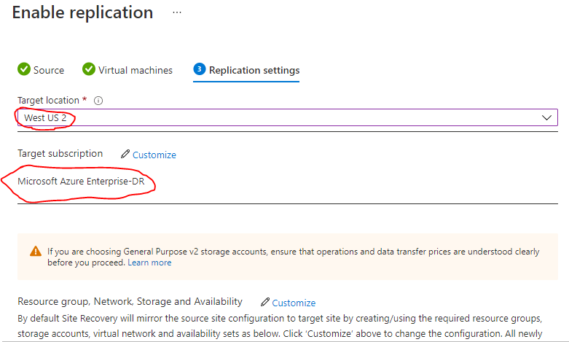

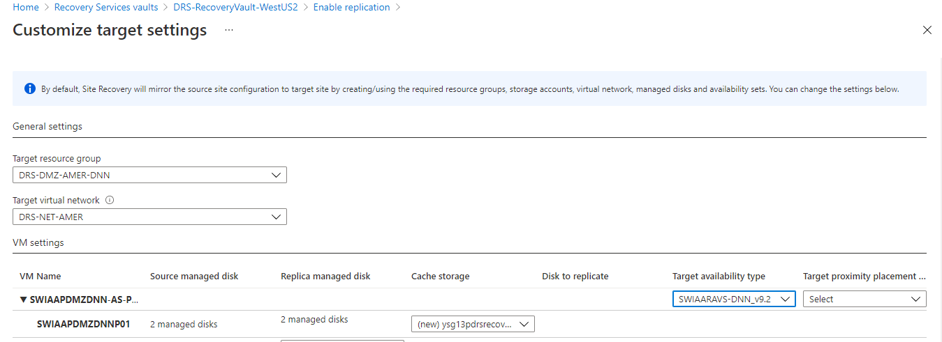

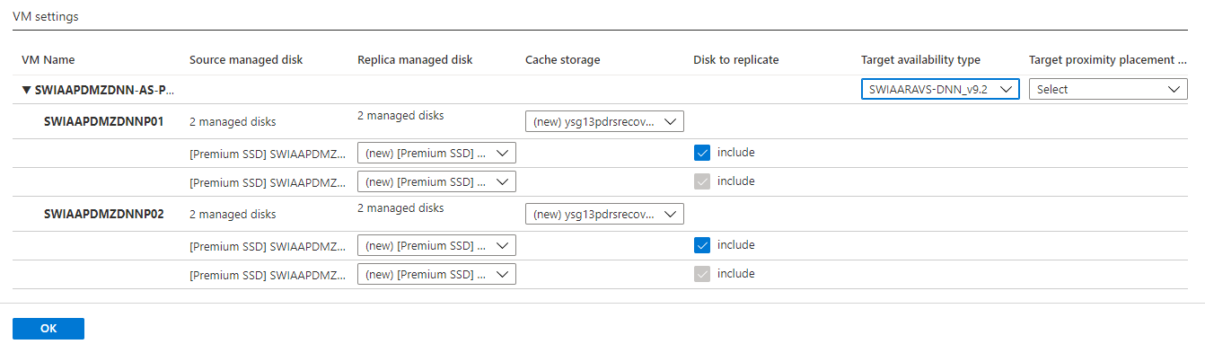

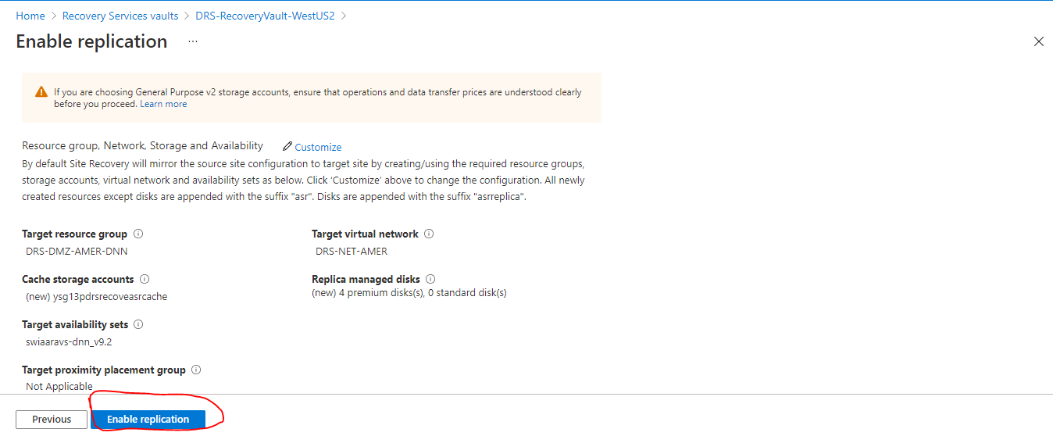

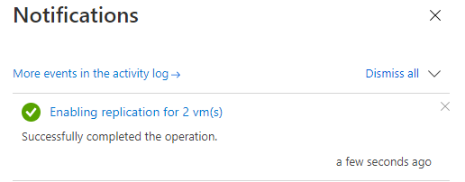

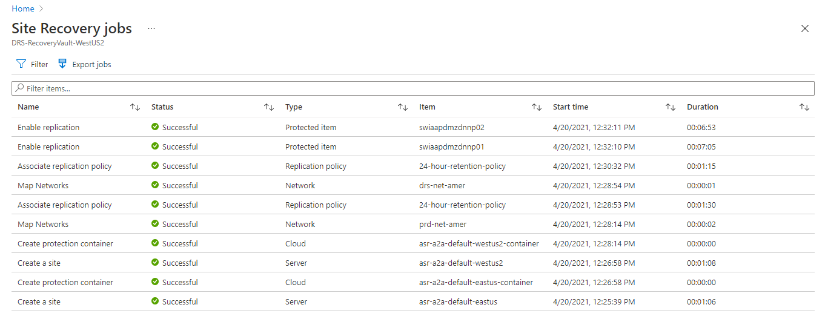

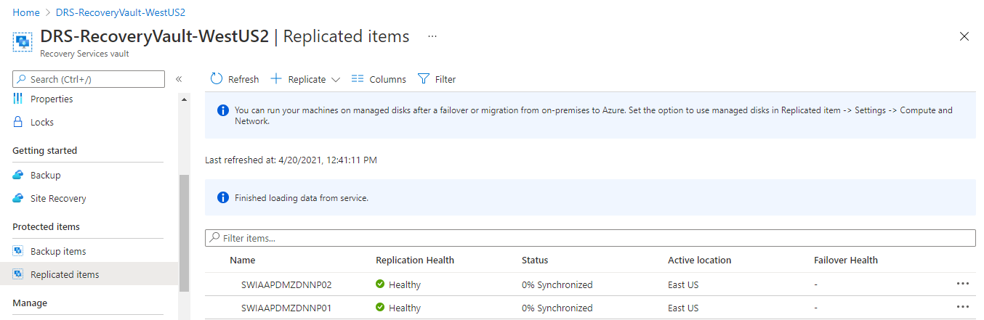

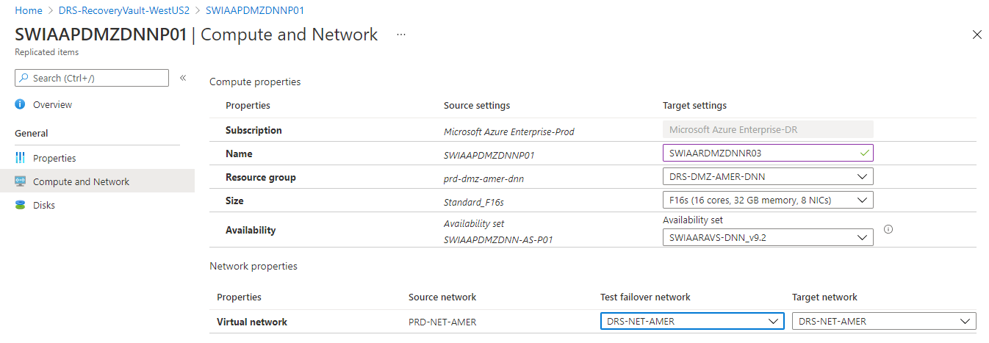

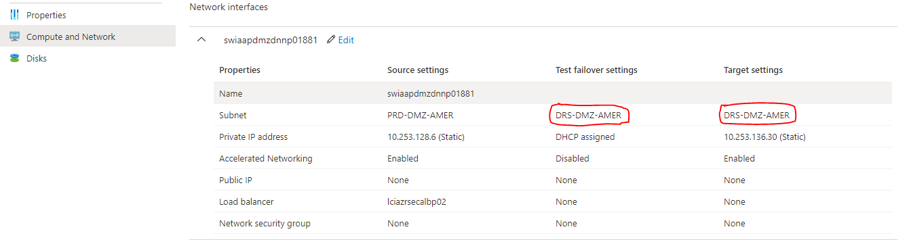

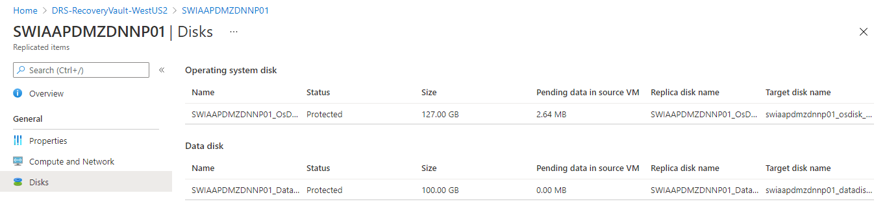

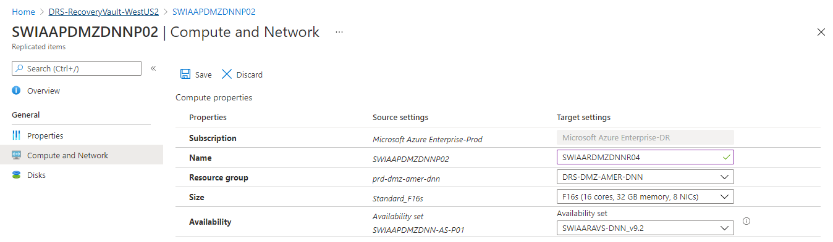

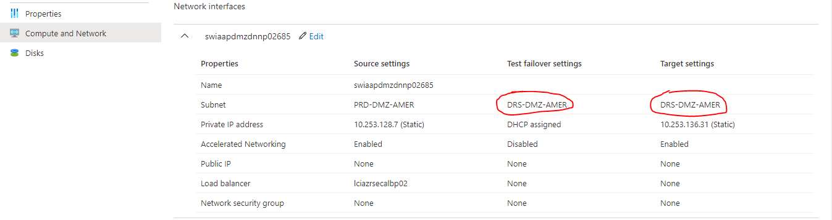

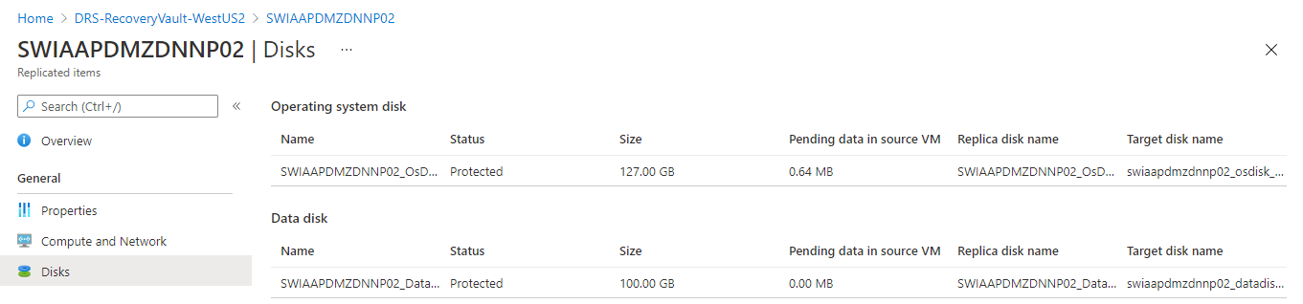

FILE SERVERS:

===============  
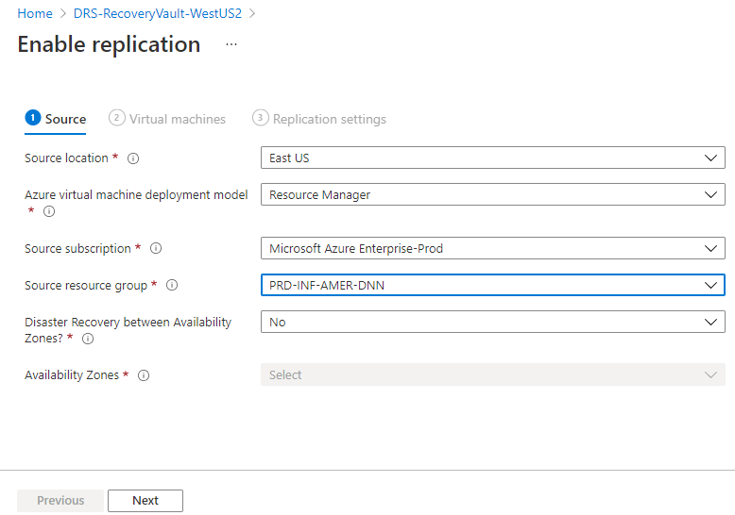

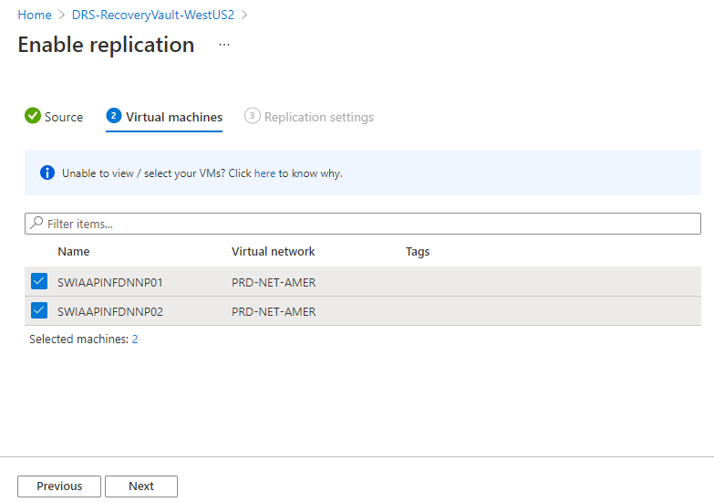

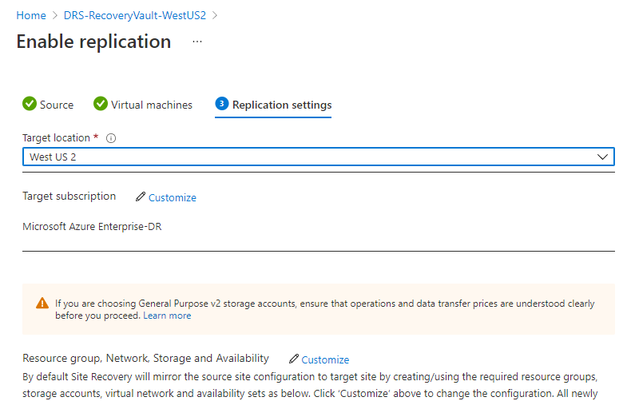

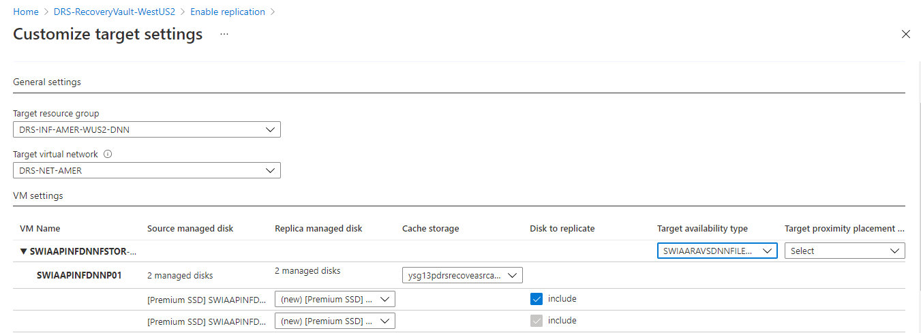

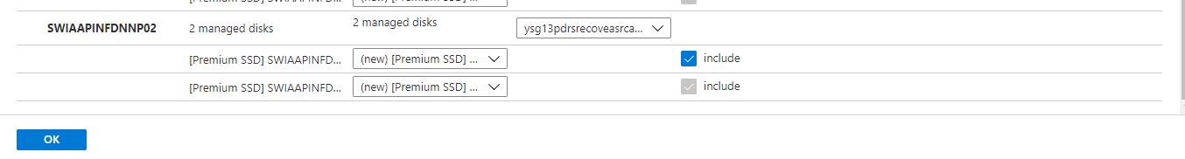

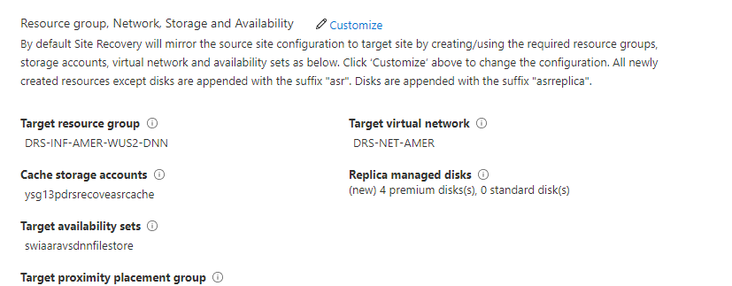

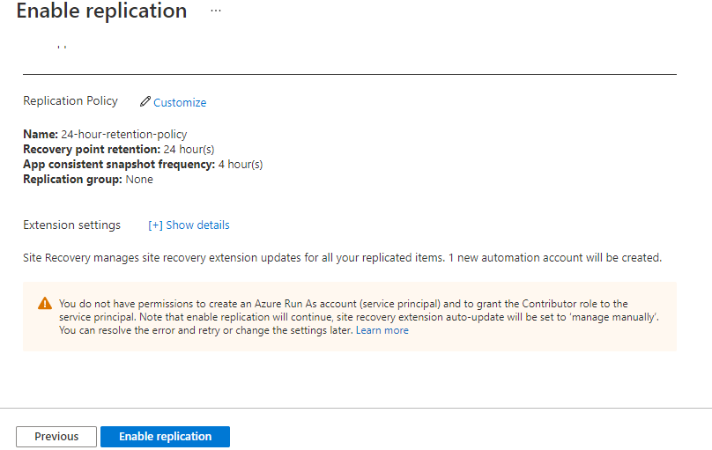

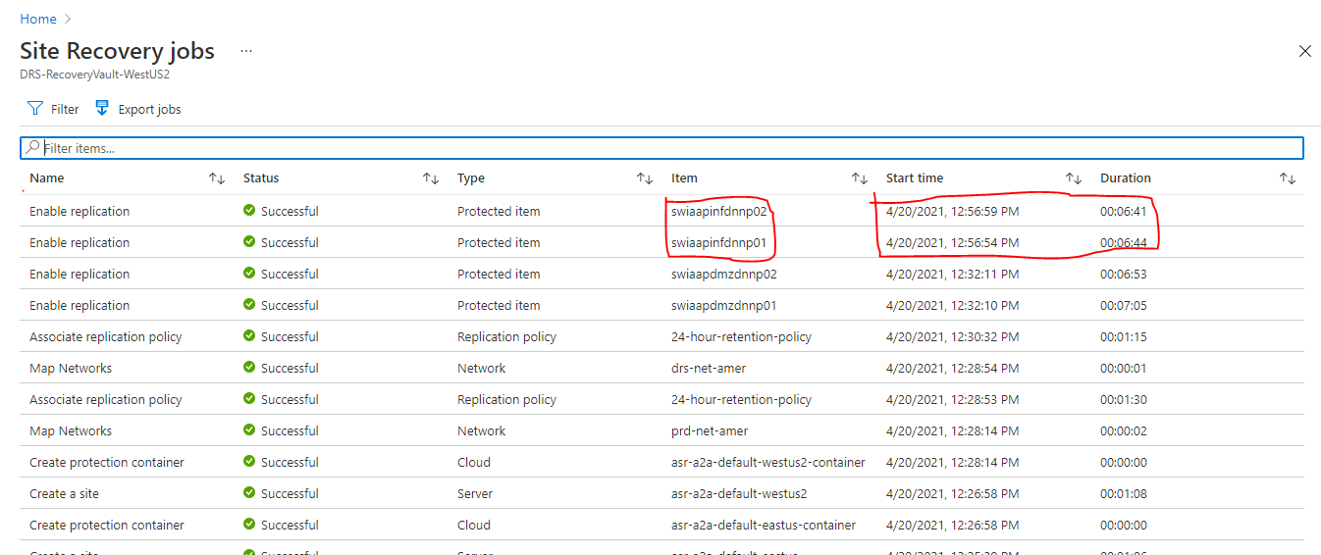

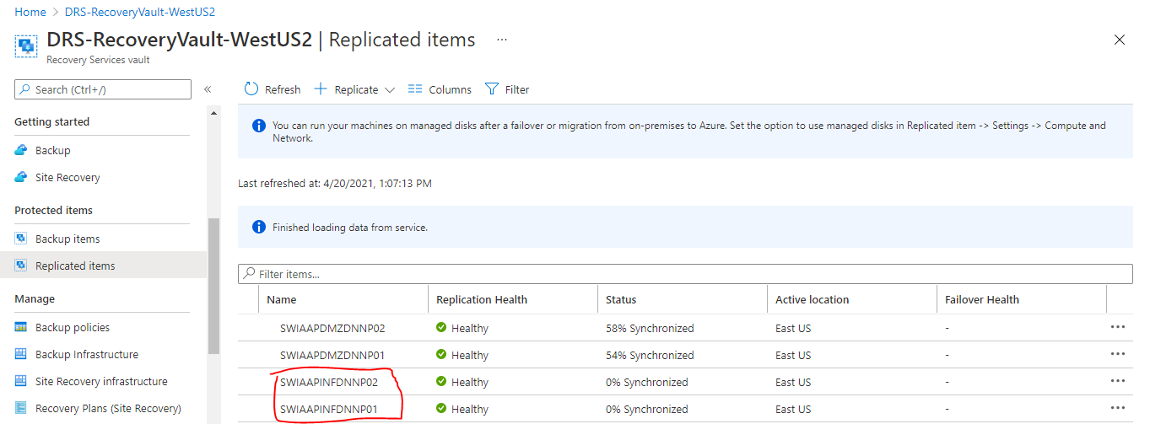

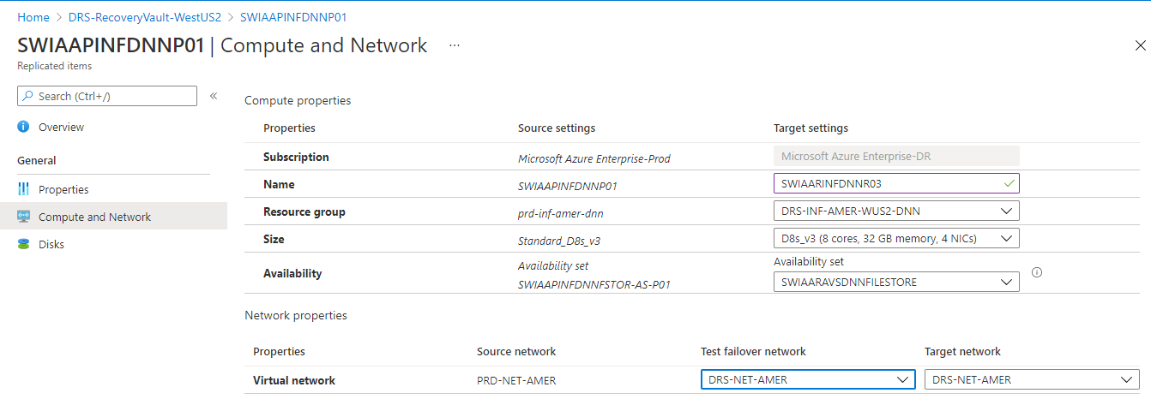

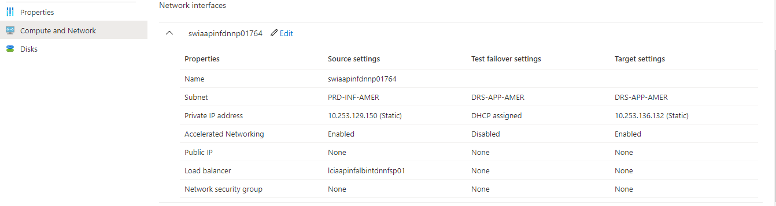

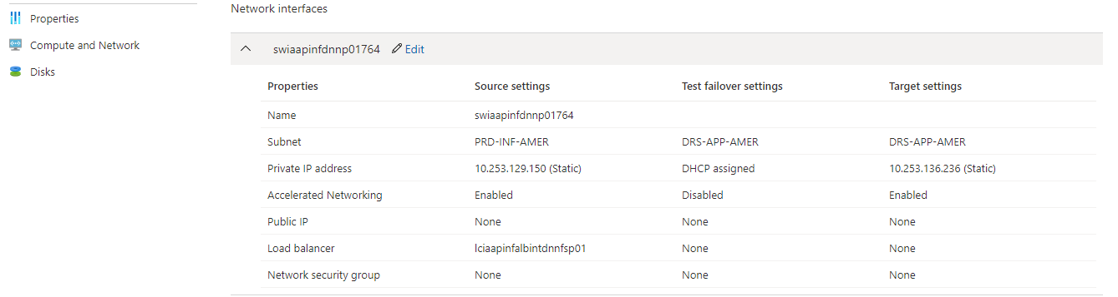

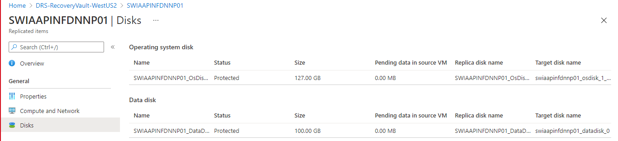

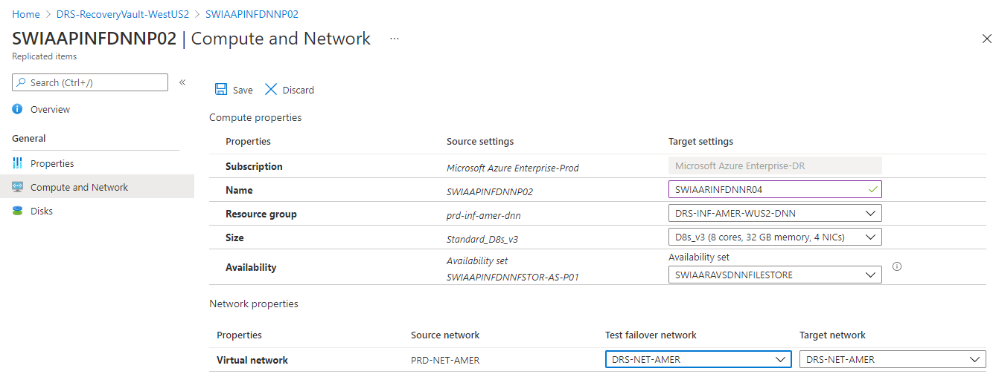

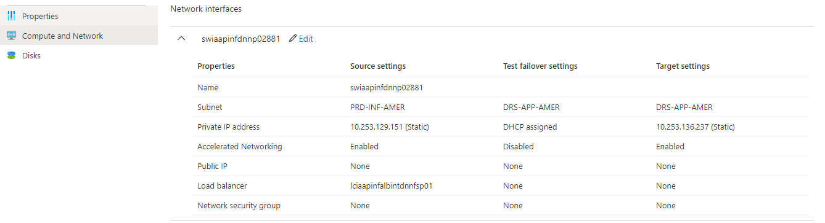

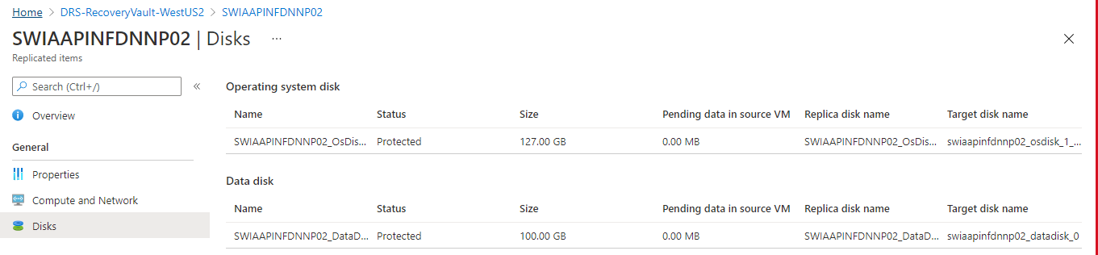

DATABASE SERVER:

==================  
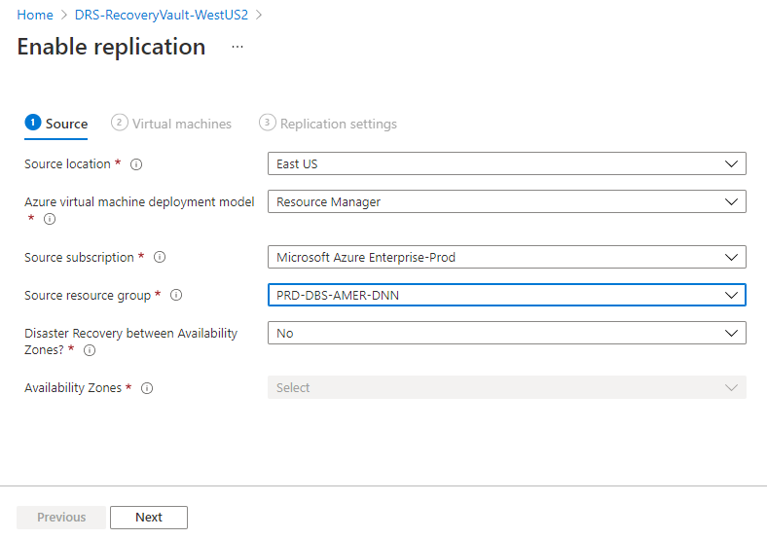

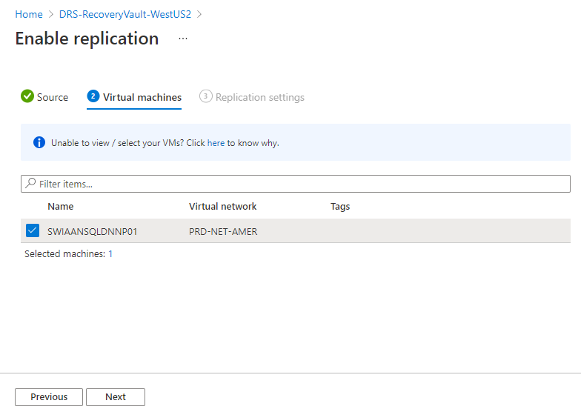

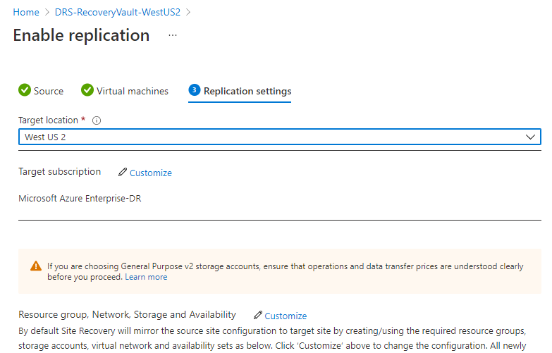

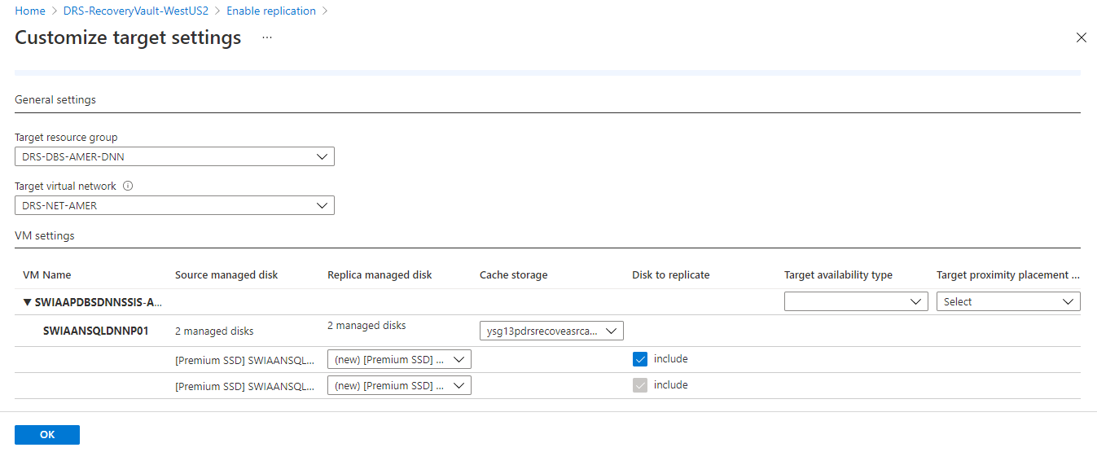

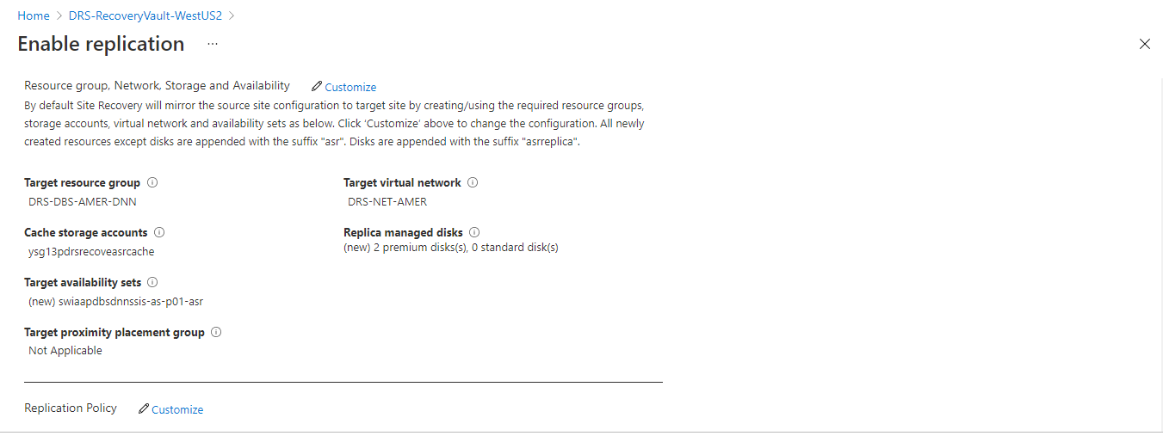

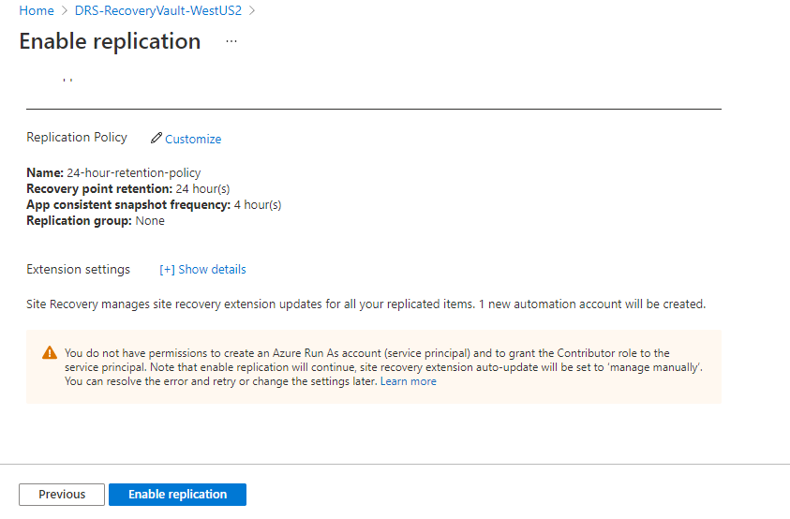

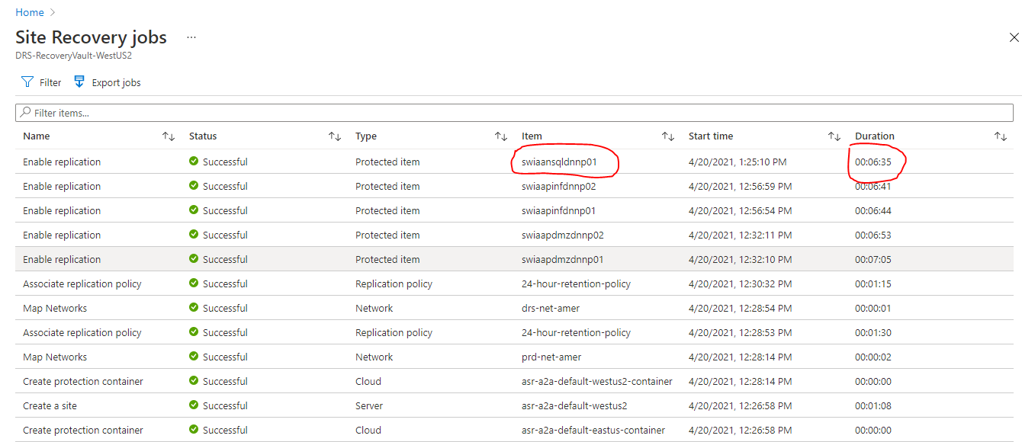

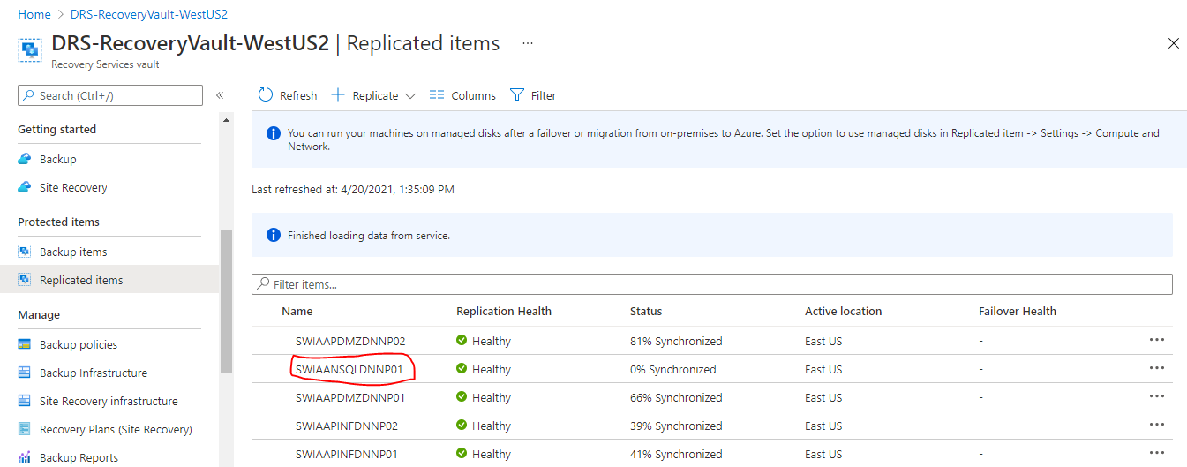

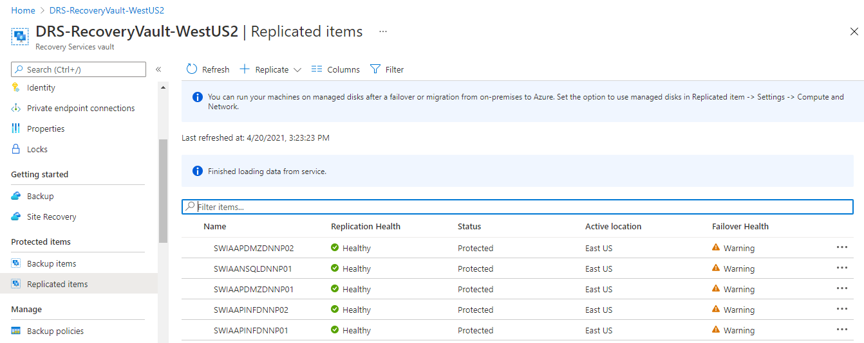

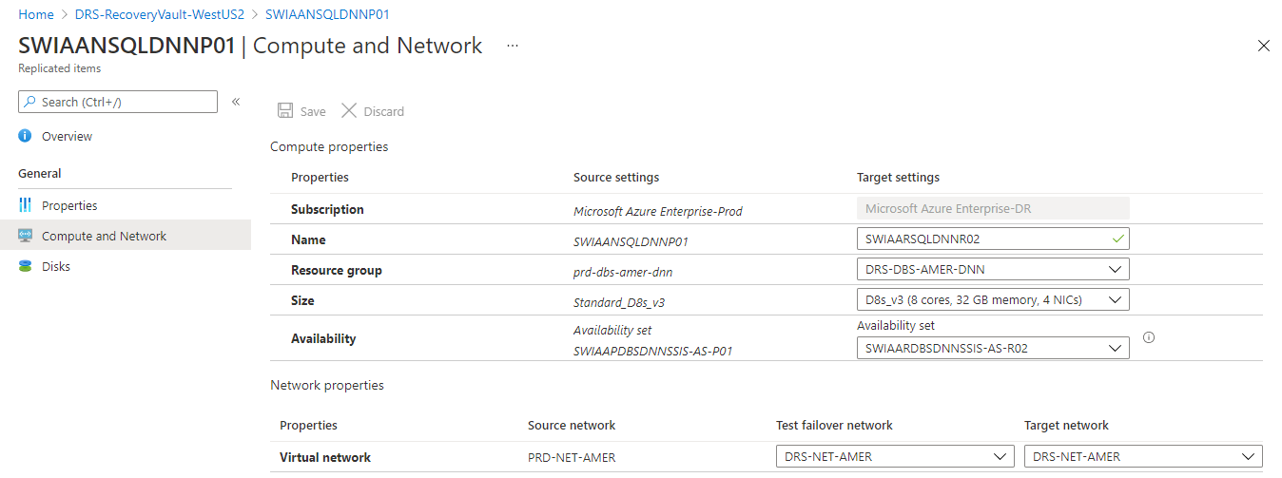

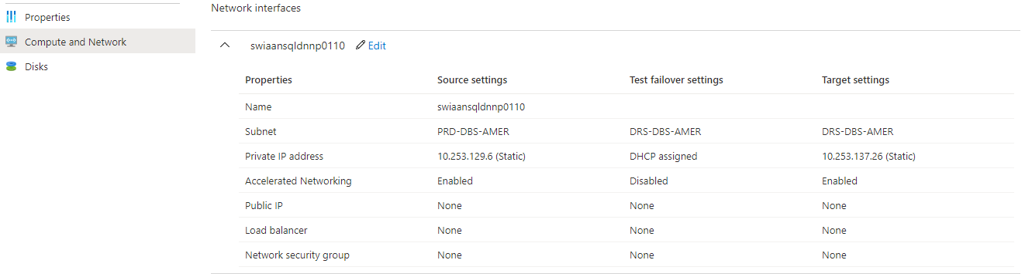

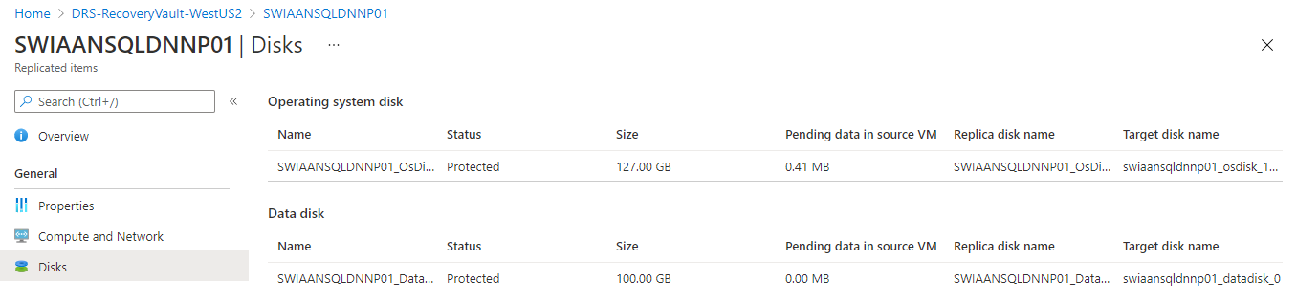

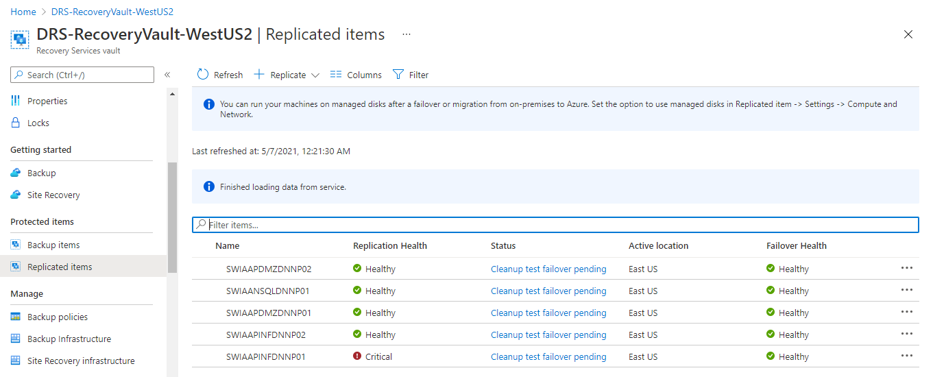

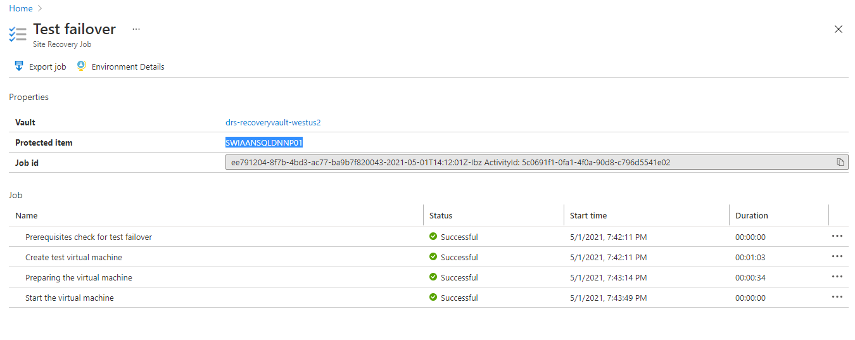

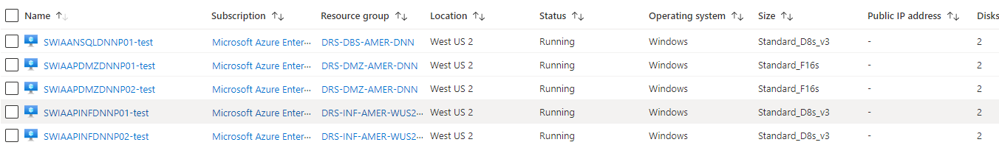

Failover:

=========

